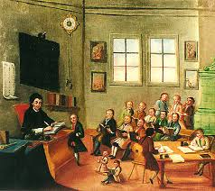
English 468/564
The TEACHING of LITERATURE

Tuesdays/Thursdays
from 2:00 till 3:15

This is where:
- theory meets practice, and we learn to love prose, poetry, and drama;
- we read, think, discuss, and write about all kinds of books;
- we learn how to make text exploration interesting for students;
- we grow as professionals;
- are interacting as colleagues.

Questions? – Email to Dr. Pitre at Leilya.Pitre@selu.edu

