In Search of Lost Time: Proust, Paris, and the Art of the Self

English 487/587: Major World Authors
Spring 2017: Monday/Wednesday, 9:30-10:45
Dr. Tom Fick

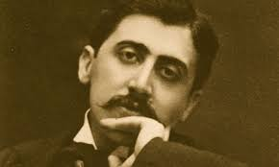

Marcel Proust’s semi-autobiographical novel, In Search of Lost Time (A la recherche du temps perdu) has been called the greatest novel ever written. Set mostly in Paris and the fictional seaside town of Balbec (the real-life Cabourg) in the late 19th and early 20th centuries, La recherche documents the narrator’s search for his vocation as a writer as he makes his way through the brilliant but deceptive world of the French aristocracy. A work of great comic genius, La recherche is also a profound investigation of art, aesthetics, and hetero/homosexual desire.

In addition to reading selections from La recherche, we will view recent film adaptations, and explore the art, music, politics, and philosophy that shaped the novel.

