Southeastern Louisiana University School of Nursing Chapter of
the American Assembly for Men in Nursing

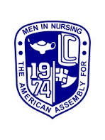

Southeastern Louisiana University School of Nursing was the first nursing program in the state to organize a student-led chapter of the American Assembly for Men in Nursing (AAMN). The School of Nursing Chapter was officially chartered by AAMN in 2009.
The mission of the AAMN Chapter is to provide a framework for nursing students, as a group, to meet, to discuss, and influence factors which affect men as nursing students and future professional nurses. Membership in the School of Nursing AAMN Chapter is open to all nursing majors, including those enrolled in prerequisite nursing courses. Membership is not restricted to men only. Any nursing major who is interested in encouraging men of all ages to become nurses, supporting men who are nursing majors to successfully complete the baccalaureate nursing program, and educating others about men in nursing and men’s health issues, are asked to join the AAMN Chapter.
For additional information about the School of Nursing AAMN Chapter, please contact one of the following faculty advisors:
Dr. Danny Lee Oscar.Lee@selu.edu
The American Assembly for Men in Nursing
http://www.aamn.org/

