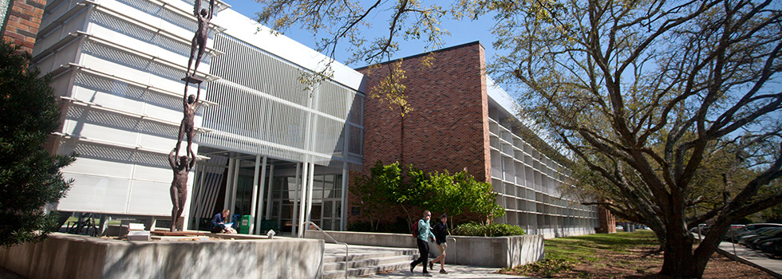

Louisiana Digital Health Institute and the Center for Digital Health in the College of Nursing and Health Sciences established with funding via DOL, HRSA and USDA grants.

In March 2020, due to the COVID-19 pandemic, students in the College of Nursing and Health Sciences (CNHS) moved to remote learning, including clinical experiences, practicums, and labs. Professionals such as nurse practitioners, counselors, and speech pathologists all nimbly and expertly transitioned to provide care using telehealth services. Grant funding sought before and during COVID-19 will be used for the CNHS to redesign space and purchase equipment to promote the ability to simulate, train, and deliver health care services from campus and elsewhere.

Health workforce development and training programs need skilled faculty and innovative technology to support the digital learning needs of health students entering the workforce and those already working. Digital health technologies facilitate patient-centered, accessible, safe, and more efficient care.

We are pleased to announce that the CNHS has received five grants to support the Louisiana Digital Health Institute (LDHI) and the Center for Digital Health (CDH). The vision for the LDHI includes shaping the future of digital health through interprofessional collaboration, exploration, and training. The Center aims to educate and train health professionals to use digital tools and technologies to engage consumers in managing their health and wellness. The pandemic has pushed digital health solutions into the spotlight. The future of healthcare requires leaders to educate and empower their workforce to build digital health capacity through education and training that enables new care models such as virtual and remote care delivery to achieve consumers' goals.

To date, the College of Nursing and Health Sciences has received over $5.4 million in grants to support the Louisiana Digital Health Institute and Center for Digital Health initiative. This workforce document was funded (68%) by grants awarded to Southeastern Louisiana University by the U.S. Department of Labor, Employment and Training Administration.

Creel, Eileen - PI | The Rural Nurses Career Advancement Pathway (RN-CAP) Program 2019-20 | U.S. Department of Labor, Employment and Training – 3-year grant for $2.3 million
Creel, Eileen PI | Louisiana Digital Health Institute (LSHI) 2021-2024 | U.S. Department of Labor, Employment and Training – 3year grant for $1.4 million
Tillman, Ken -PI | Louisiana Increasing Opportunities for Nurse Veterans in Primary Care (LION VIP CARE) 2019-20 | HRSA - 3-year grant for $1.5 million
Tillman, Ken-PI | Nurse Education Practice Quality Retention Veteran Nurses in Primary Care COVID | HRSA - 1-year grant for $65,285
Carruth, Ann - PI | USDA RUS Distance Learning | $173,920

In a few short months, the CNHS has identified several collaborating partners with the LSHI / CDH initiative and has a dedicated space in the Kinesiology and Health Sciences Annex (KHSA) building on the Hammond campus. However, the technology for training is in key locations, including the Southeastern Student Health Center, the Speech-Language-Hearing Clinic, and the Baton Rouge Center for Nursing.

In the future virtual services will be offered on the Northshore Technical Community College campuses. The recently awarded 2020 USDA RUS Distance Learning grant provides telehealth and distance learning services via synchronous audio and visual technology. Through the grant, Southeastern Louisiana University will establish telehealth clinics/training centers at four Northshore Technical Community College campuses. Services provided will include mental health counseling; school and athletic team physicals; urgent care; speech therapy; health coaching for chronic disease management and nutrition: and health education centered on wellness, obesity, chronic disease, infectious disease outbreaks, and other episodic health care issues related to the region.

Recent equipment purchases include remote telehealth carts and peripherals, allowing telehealth training using virtual care best practices. The telehealth equipment will also be used in the simulation labs to provide students with enhanced interactive experiences. In the Health Center, the telehealth cart will allow virtual visits for Southeastern students with a health care provider, through a phone call or a video chat.

Dr. Luanne Billingsley, School of Nursing, will serve as the Telehealth Director. She stated, "who could imagine that the pandemic would change the care delivery model so much in a short time? We must educate and train the future workforce to be comfortable using technology to help consumers achieve their goals. I am fortunate to work with colleagues that are always going the extra mile to provide meaningful learning experiences for students." She is looking forward to working with faculty and community partners to provide Southeastern's health professional students and the area health workforce with best practice telehealth training.

